**_LAYOUT.CSHTML**

<!DOCTYPE html>

<html lang="en">

<head>

<meta charset="utf-8" />

<meta name="viewport" content="width=device-width, initial-scale=1.0" />

<title>@ViewData["Title"] - NETCORE_MVC</title>

<**link** rel="stylesheet" href="~/lib/bootstrap/dist/css/bootstrap.min.css" />

<**link** rel="stylesheet" **href**="~/css/site.css" **asp-append-version**="true" />

<**link** rel="stylesheet" **href**="~/NETCORE_MVC.styles.css" **asp-append-version**="true" />

</head>

<body>

<header>

<nav class="navbar navbar-expand-sm navbar-toggleable-sm navbar-light bg-white border-bottom box-shadow mb-3">

<div class="container-fluid">

<**a** class="navbar-brand" **asp-area**="" **asp-controller**="Home" **asp-action**="Index">NETCORE_MVC</**a**>

<button class="navbar-toggler" type="button" data-bs-toggle="collapse" data-bs-target=".navbar-collapse" aria-controls="navbarSupportedContent"

aria-expanded="false" aria-label="Toggle navigation">

<span class="navbar-toggler-icon"></span>

</button>

<div class="navbar-collapse collapse d-sm-inline-flex justify-content-between">

<ul class="navbar-nav flex-grow-1">

<li class="nav-item">

<**a** class="nav-link text-dark" **asp-area**="" **asp-controller**="Home" **asp-action**="Index">Home</**a**>

</li>

<li class="nav-item">

<**a** class="nav-link text-dark" **asp-area**="" **asp-controller**="Home" **asp-action**="Privacy">Privacy</**a**>

</li>

<li class="nav-item">

<**a** class="nav-link text-dark" **asp-area**="" **asp-controller**="Home" **asp-action**="AboutWPH">About WPH</**a**>

</li>

</ul>

</div>

</div>

</nav>

</header>

@RenderSection("FullWidthSection", required: false)

<div class="container">

<main role="main" class="pb-3">

@RenderBody()

</main>

</div>

<footer class="border-top footer text-muted">

<div class="container">

&copy; 2025 - NETCORE_MVC - <**a** **asp-area**="" **asp-controller**="Home" **asp-action**="Privacy">Privacy</**a**>

</div>

</footer>

<**script** src="~/lib/jquery/dist/jquery.min.js"></**script**>

<**script** src="~/lib/bootstrap/dist/js/bootstrap.bundle.min.js"></**script**>

<**script** **src**="~/js/site.js" **asp-append-version**="true"></**script**>

@await RenderSectionAsync("Scripts", required: false)

</body>

</html>

**HomeController.cs**

using System.Diagnostics;

using Microsoft.AspNetCore.Mvc;

using NETCORE_MVC.Models;

namespace NETCORE_MVC.Controllers

{

public class HomeController : Controller

{

private readonly ILogger<HomeController> _logger;

public HomeController(ILogger<HomeController> logger)

{

_logger = logger;

}

public IActionResult Index()

{

return View();

}

public IActionResult Privacy()

{

return View();

}

public IActionResult AboutWPH()

{

return View();

}

[ResponseCache(Duration = 0, Location = ResponseCacheLocation.None, NoStore = true)]

public IActionResult Error()

{

return View(new ErrorViewModel { RequestId = Activity.Current?.Id ?? HttpContext.TraceIdentifier });

}

}

}

**AboutWPH.cshtml**

@{

ViewData["Title"] = "About WPH";

}

@section FullWidthSection {

<div class="full-bg">

<h1>About WPH</h1>

<p>

This is my custom WPH about page. For official WPH about page ->

<a href="https://wphdigital.com/about" class="custom-link" target="_blank">Official WPH About Page</a>.

</p>

</div>

}

<div class="purpose">

<h1 class="what"> What do we do?</h1>

<h3> We deliver IT Consulting Services and Technology Services from innovation to execution </h3>

<p>

WPH Digital, we are a multi-disciplinary company that offers a range of IT consulting services and implementation expertise, including digital transformation, digital strategy, technology implementation, artificial intelligence, data analytics, cybersecurity and cloud computing.</p>

<p> We work together with clients to leverage new technologies to reshape their business, invent new products or transform their organisation, in search of growth opportunities and cost optimization. We’ve got a deep understanding of both the technical and user complexities that come with large and regulated environments, integration of multiple systems, stakeholder and change management.

</p>

</div>

<div class="glance">

<h1 >AT A GLANCE</h1>

<h3>_________________</h3>

</div>

<div class="floating-container">

<div class="floating-box">

<h2 class="boxHeader">28+ YEARS</h2>

<p>Established since 1997 in Singapore, WPH is a full service digital solution delivery agency, with technology as our core.</p>

</div>

<div class="floating-box">

<h2 class="boxHeader">1000+ PROJECTS</h2>

<p>We work hard to understand the strategies and focuses of our clients so our work can be more relevant, aligned and long-term.​</p>

</div>

<div class="floating-box">

<h2 class="boxHeader">4 OFFICES</h2>

<p> We provide a full range of Digital Services and Technology Solutions to clients in Singapore, Malaysia, Philippines, and Thailand. </p>

</div>

</div>

<div class="glance">

<h1>PARTNERS & ALLIANCES</h1>

<h5 class="boxHeader">TO INNOVATE. WE COLLABORATE</h5>

<div class="glanceBody">

<p>We partner with market leading technology partners to deliver the best industry solutions for our customers.</p>

<p> We know the market and the latest technologies. Our established strategic relationships with the variety of broad enterprise technologies help ensure we are able to continue to offer a greater breadth and depth of services, enrich our own capabilities, and add value to the strategies we develop for our clients.</p>

</div>

</div>

<div class="floating-container">

<div class="floating-box">

<h2 class="boxHeader"><a href="https://www.microsoft.com/en-ph">MICROSOFT</a></h2>

<img class="logo" src="@Url.Content("~/images/microsoft.png")" alt="Microsoft Logo" />

</div>

<div class="floating-box">

<h2 class="boxHeader"><a href="https://aws.amazon.com">AWS</a></h2>

<img class="logo" src="@Url.Content("~/images/awslogo.jpg")" alt="AWS Logo" />

</div>

<div class="floating-box">

<h2 class="boxHeader"><a href="https://www.oracle.com">Oracle</a></h2>

<img class="logo"src=" @Url.Content("~/images/oracle logo.png")" alt="Oracle Logo" />

</div>

</div>

<div class="floating-container">

<div class="floating-box">

<h2 class="boxHeader"><a href="https://wphdigital.com/wph-service-excellence">DELIVERING SUCCESS & EXPERIENCE</a></h2>

<h2 class="boxHeader"> DRIVING RESULTS</h2>

<img class="logo" src="@Url.Content("~/images/WPHlogo.png")" alt="WPH Logo" />

</div>

<div class="floating-box">

<h2 class="boxHeader"><a href="https://wphdigital.com/wph-service-focus">SERVICE DISCIPLINES </a></h2>

<h2 class="boxHeader"> CAPABILITY AND CAPACITY </h2>

<img class="logo" src="@Url.Content("~/images/WPHlogo.png")" alt="WPH Logo" />

</div>

</div>

**site.css**

html {

font-size: 14px;

}

@media (min-width: 768px) {

html {

font-size: 16px;

}

}

.btn:focus, .btn:active:focus, .btn-link.nav-link:focus, .form-control:focus, .form-check-input:focus {

box-shadow: 0 0 0 0.1rem white, 0 0 0 0.25rem #258cfb;

}

html {

position: relative;

min-height: 100%;

}

body {

margin-bottom: 60px;

}

.full-bg {

width: 100%;

background-color: #b10000;

color: white;

padding: 30px 20px;

margin: 0;

}

.custom-link {

color: white;

text-decoration: underline;

}

.custom-link:hover {

color: #ddd;

}

.what {

color: #b10000;

margin: 20px 0px;

}

.glance {

margin: 50px 0;

text-align:center;

}

.glanceBody{

text-align:justify;

}

.floating-container {

display: flex;

justify-content: center;

gap: 20px;

margin-top: 40px;

}

.floating-box {

background-color: white;

padding: 20px;

width: 1000px;

border-radius: 15px;

box-shadow: 0 4px 10px rgba(0, 0, 0, 0.2);

}

.boxHeader {

color: #b10000;

}

.logo {

width: 120px;

height: 120px;

object-fit: contain;

display: block;

margin: 0 auto;

}

.logo-img:hover {

transform: scale(1.05);

}

**WEBSITE OUTPUT**

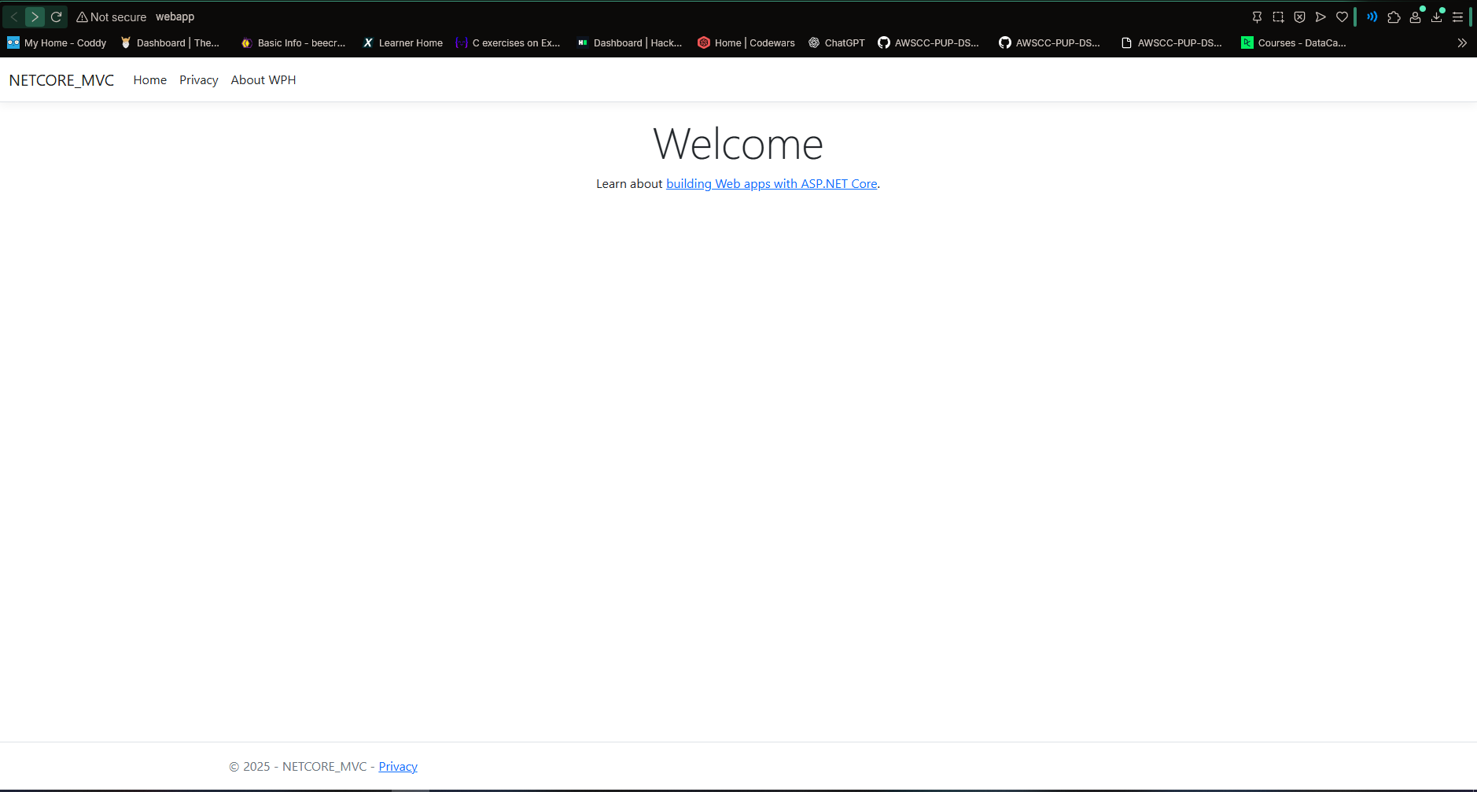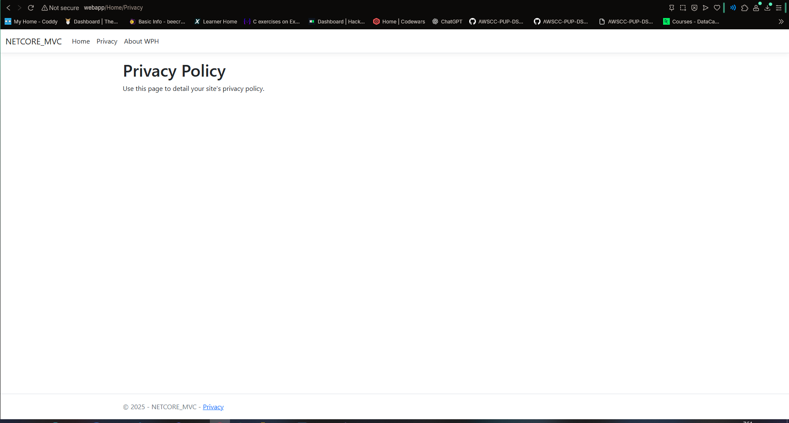

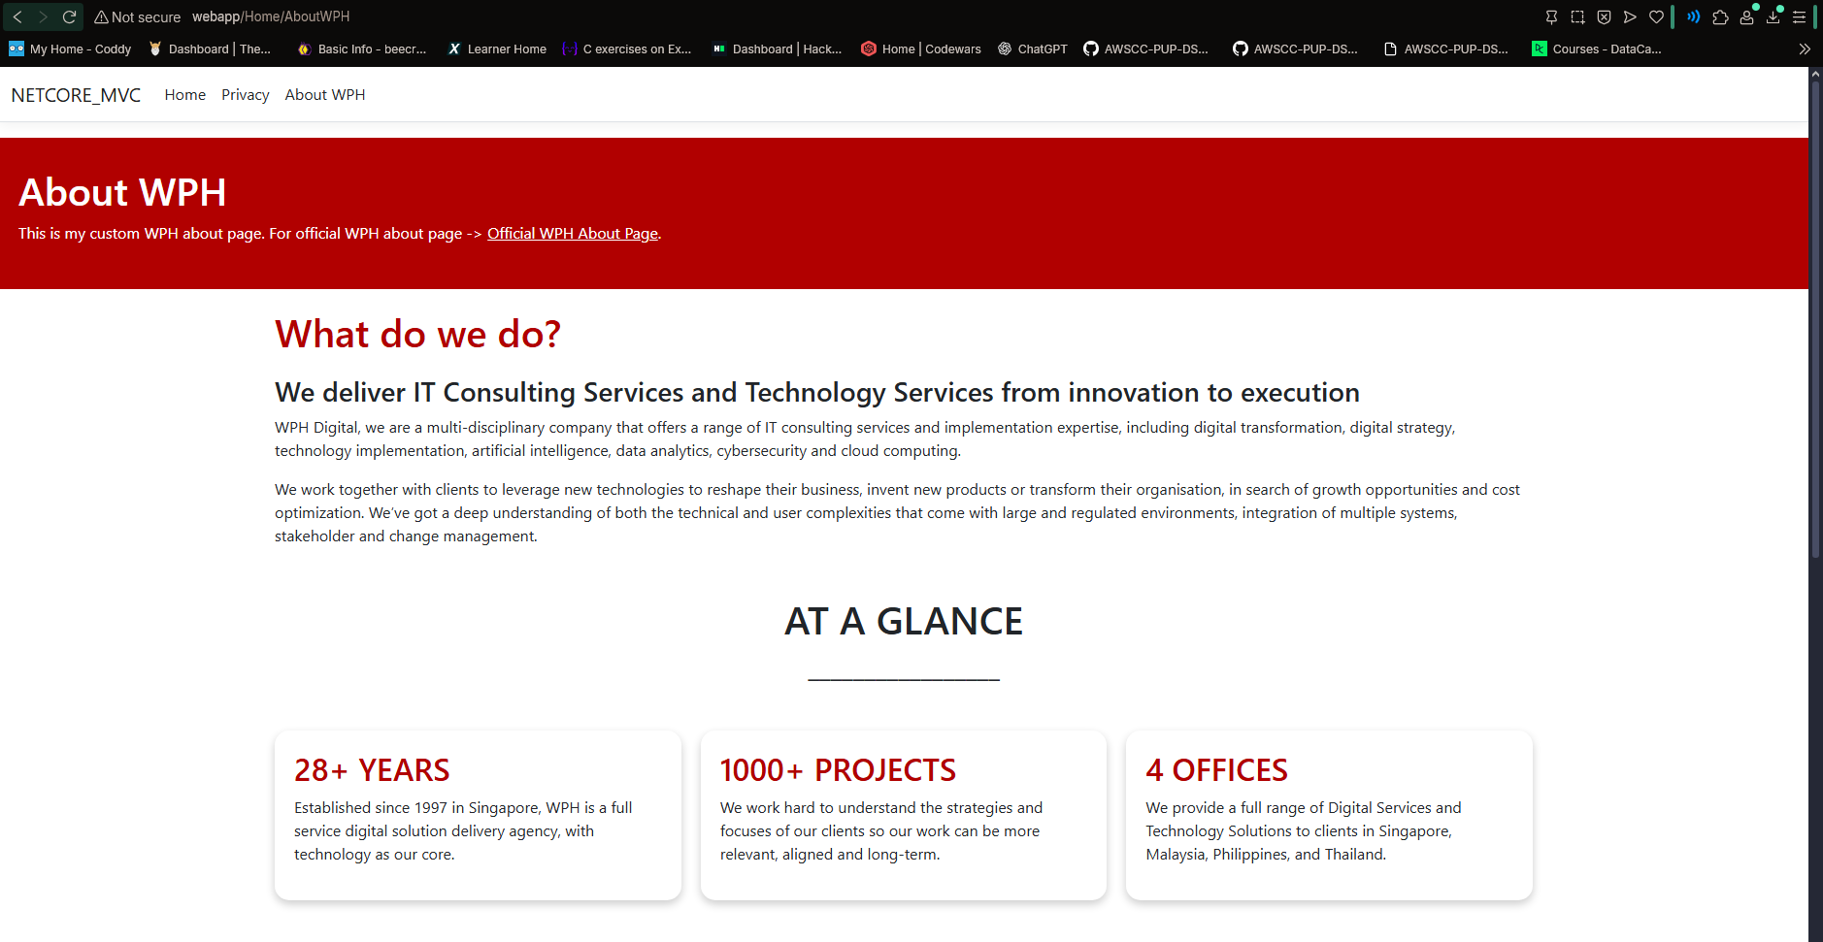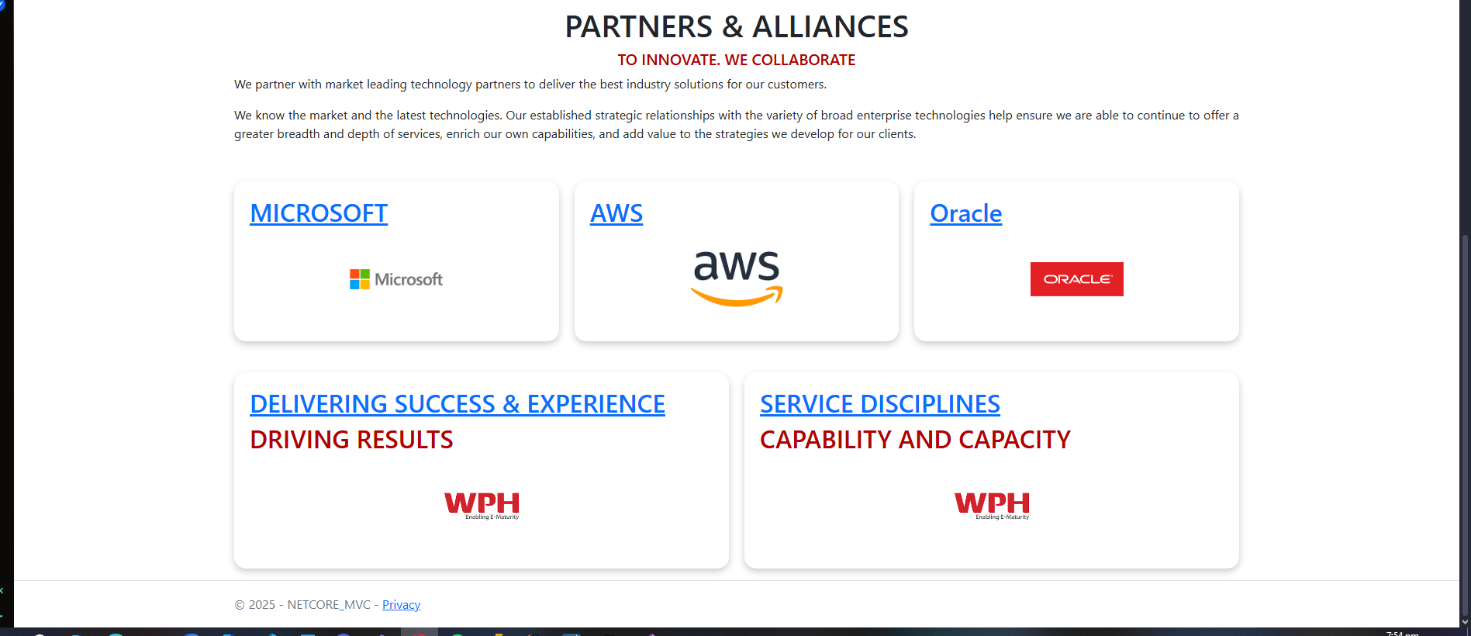

**LINK TO OFFICIAL ABOUT WEBSITE**

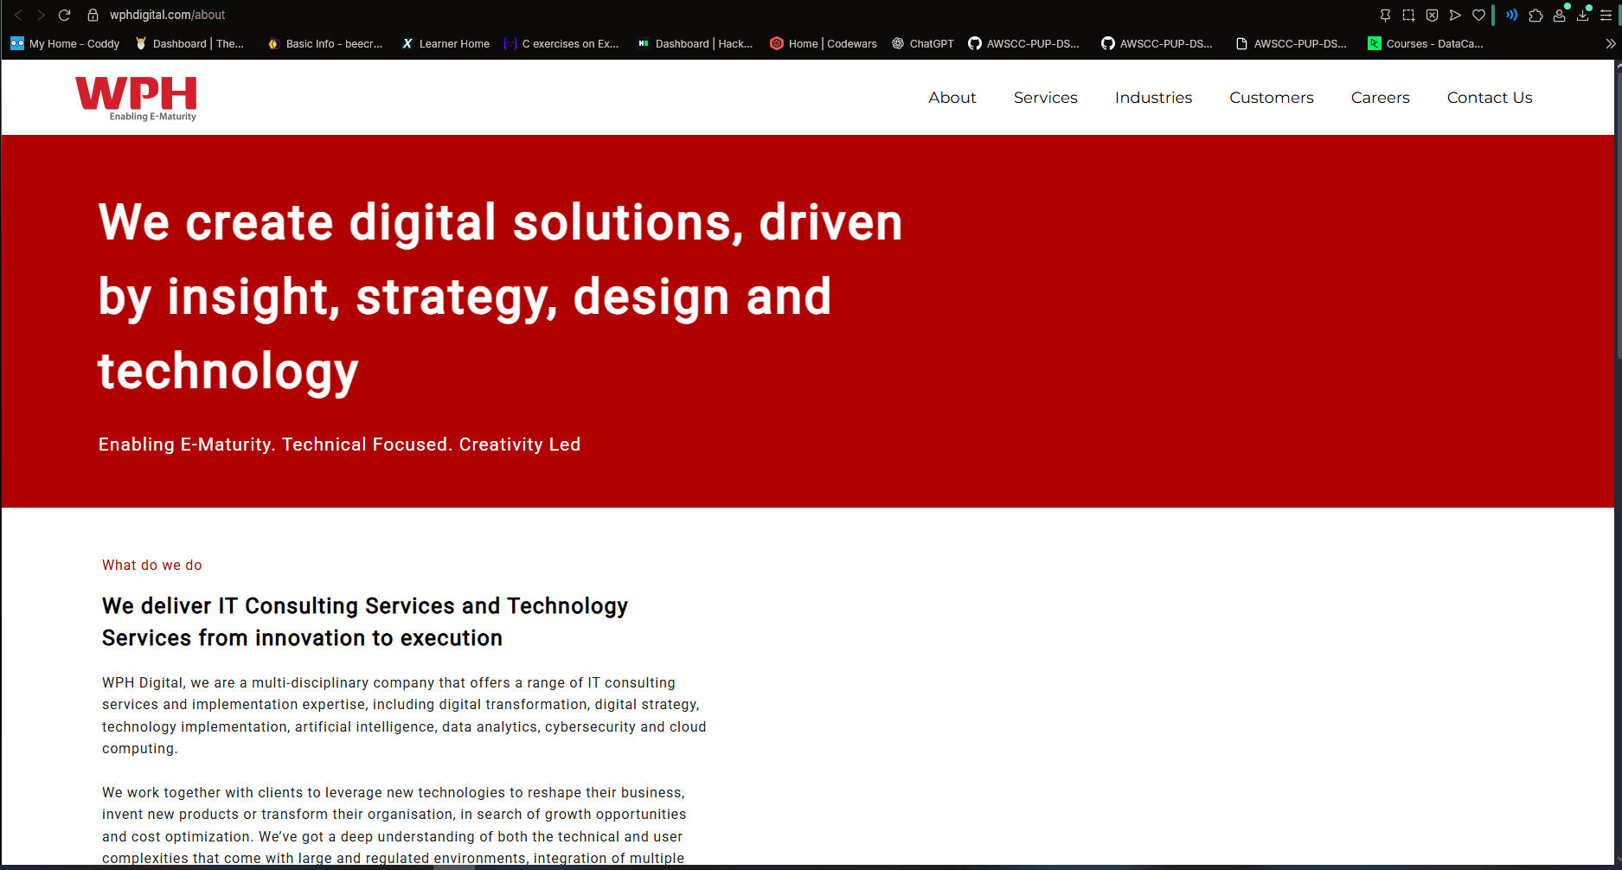

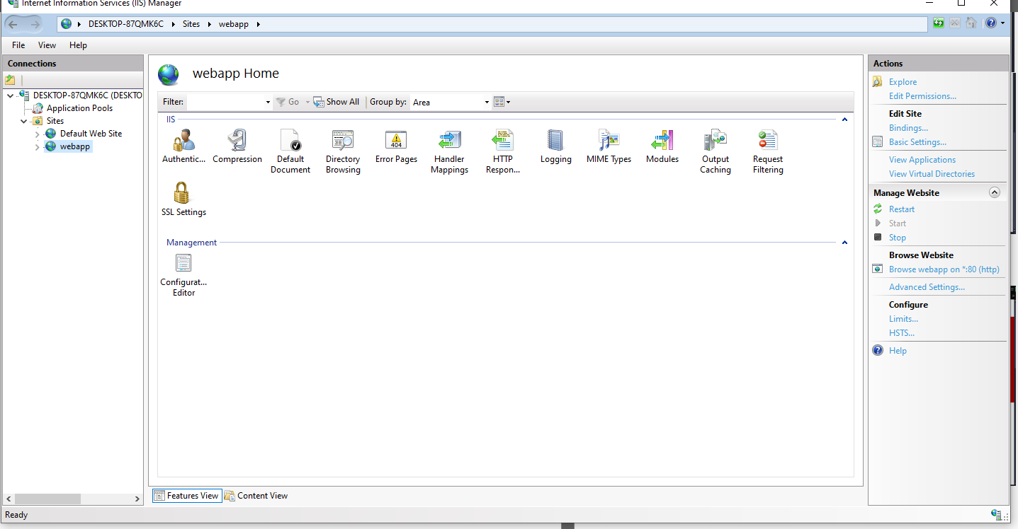

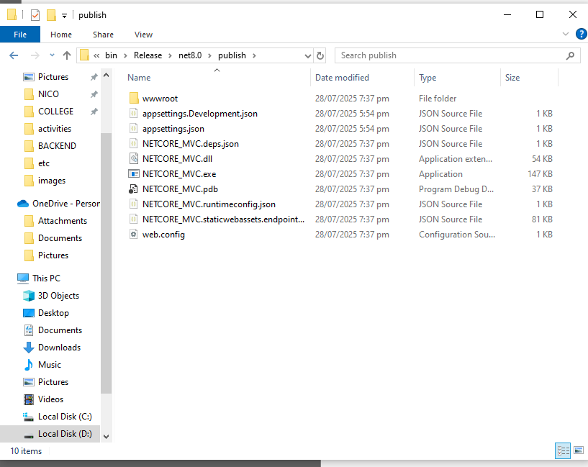

**REFLECTION**

Creating a .NET Core application was both a learning experience and a challenge. At first, I was overwhelmed by how many files were involved like Views, Controllers, CSS, Razor files, and the wwwroot folder. It wasn’t easy to figure out where everything should go, especially when I was trying to design my pages. I’m not really into front-end design, so styling the layout, aligning elements, and making things look clean was frustrating at times.

Throughout the project, I had to constantly search on Google to answer questions—whether it was how to add images properly, use Razor syntax like @Url.Content(), or center elements on the page. Despite that, I managed to create a custom “About WPH” page with my own design, and I added a working link that leads to the official WPH about page so users can access both.

In addition, I included logos for WPH’s partner companies like Microsoft, AWS, and Oracle. I added working links to their official websites, styled the logos to be consistent in size, and placed them in floating containers to improve the visual layout. Getting them to align properly and look clean required a lot of CSS tweaking.

Overall, building this project forced me to really dig into .NET Core and understand how everything connects. It’s still confusing sometimes, but I now understand Razor Pages better and how content flows from the controller to the view. I also learned how powerful .NET Core can be once you get the hang of it, and I feel more confident with every small win I had during the process.